

Software Engineering Department
Braude - College of Engineering
Capstone Project Phase B – 61999

Pedagogical Training
Project code: 25-2-D-17
Supervisor:
Dr. Natali Levi-Soskin

Authors:
Celin Asadi 324300706
Anood Naem 324222553

Github link :

https://github.com/CelineAsadi/Pedagogical-Training-project.git

VIDEO TUTORIAL (SHORTER VERSION 2:00 MIN )
VIDEO-2026-01-28-12-23-44.mp4

Table Of Contents

Table Of Contents 2
Abstract 3
1 – Problem Overview and Background 3
1.1 Problem Overview 3
1.2 Limitations of Existing Training Methods 4
1.3 Motivation for the Project 5
1.4 Project Goals 5
2 – System Description & Achievements 6
2.1 General Description of the System 6
2.2 System Architecture Overview 7
2.2.1 High-Level Architectural Structure 7
2.3 Activity diagram 9
2.4 Project Achievements 9
2.5 Deployment 10
3 – Development Process 10
3.1 Development Methodology and Critical Reflections 10
3.2 Tools and Technologies Used 11
3.3 Interaction with Stakeholders and Usability Evaluation 12
3.4 Design Decisions and Justifications 13
3.5 Project Compliance with Defined Performance Indicators 13
4 – Results 14
4.1 Evaluation Against Project Metrics 14
5 – Conclusion and Future Work 16
6 – Challenges and Solutions 17
6.1 Defining Conditions for Generating Student Disruptions 17
6.2 Hebrew Speech Processing and Transcription 17
6.3 Session Isolation Between Simulations 18
6.4 Real-Time Event Synchronization 18
6.5 Generating Meaningful and Pedagogically Relevant Feedback 18
References 19

Abstract
Classroom management remains one of the most significant challenges for early-career teachers, often leading to professional stress, burnout, and high attrition rates. Existing teacher education programs, while offering theoretical foundations, frequently fail to equip educators with practical tools for handling real-time behavioral disruptions. This project introduces an innovative pedagogical training system designed to bridge this gap through interactive, AI-powered classroom simulations. The system allows teachers to respond vocally to simulated student misbehavior in a virtual environment, where student disruptions are dynamically generated by AI based on the classroom context and teacher behavior. At the end of each simulation session, teachers receive a structured and personalized pedagogical summary generated from all feedback produced throughout the session. The feedback includes quantitative scores and qualitative insights related to response timing, emotional tone, pedagogical effectiveness, and overall classroom management performance. The summary is based on analysis of the teacher’s verbal responses, emotional tone, response timing, and pedagogical handling of classroom events. Using AI-driven voice recognition and voice analysis, the system evaluates response effectiveness, aggregates performance metrics across the session, and enables tracking of teacher progress over time. The system was evaluated through a usability study using the System Usability Scale (SUS), completed by early-career teachers after interacting with the system, yielding a mean SUS score of 85.9, which indicates a high level of usability. Participants reported that the system is intuitive, easy to use, and supportive of professional learning, highlighting its potential value as a complementary tool in teacher education programs.

1 – Problem Overview and Background

1.1 Problem Overview
Classroom management is widely recognized as one of the most persistent and demanding challenges faced by early-career teachers. Many novice educators struggle to cope with student inattentiveness, recurring disruptions, interpersonal conflicts, and defiant behavior toward teacher authority. These difficulties negatively affect the learning environment and significantly undermine teachers’ sense of competence, confidence, and professional stability.
International research consistently indicates high attrition rates among new teachers. Approximately 30% of novice teachers leave the profession within their first year, and nearly 50% exit within the first five years, with classroom behavior management identified as a major contributing factor to this phenomenon [2]. The transition from theoretical training to real classroom practice often exposes a substantial gap between what teachers learn during their studies and the complex, unpredictable reality they face in schools. This gap frequently results in emotional overload, frustration, and early professional burnout [1][3].
Although teacher education programs typically include courses on classroom management, these courses tend to remain largely theoretical. They often focus on idealized scenarios and predefined strategies, failing to reflect the dynamic, emotionally charged, and situational nature of real classroom environments[2]. As a result, many teachers begin their careers without sufficient practical experience or confidence to respond effectively to disruptive behaviors, particularly under pressure [4].
This challenge is also evident within the Israeli education system. According to the Israeli Ministry of Education’s National Report (2023), classroom disruptions are among the most frequently reported difficulties faced by new teachers, with approximately 28% identifying behavior management as their primary challenge during the induction year[5] . Additionally, surveys conducted by the Central Bureau of Statistics (CBS, 2022) report a continuous rise in teacher burnout, especially among early-career educators who often feel unprepared to manage complex behavioral situations[6]. These findings emphasize the national relevance and urgency of strengthening classroom management training within teacher preparation frameworks.

1.2 Limitations of Existing Training Methods
Current support mechanisms for novice teachers include professional development workshops, pedagogical mentoring, and classroom observations. While these tools provide important guidance, they suffer from significant limitations[1][3][2].
Professional workshops introduce classroom management strategies but often lack opportunities for repeated practice, personalization, and real-time feedback. Pedagogical mentoring offers contextual support but is usually limited in frequency and scope, and rarely exposes teachers to a wide variety of disruptive scenarios[2[5]. Classroom observations tend to capture routine instructional moments and seldom include severe, emotionally complex behavioral events[4][1].
Consequently, traditional training methods do not consistently provide the experiential, repetitive practice required for developing strong classroom management skills[4][2].
Technological solutions such as educational simulations (e.g., SimSchool[11]) have attempted to address this gap by offering virtual teaching environments. However, most existing platforms primarily focus on instructional decision-making and learning differentiation, rather than on real-time behavioral disruptions and emotional classroom dynamics. As a result, they do not fully capture the situational complexity and emotional intensity associated with managing disruptive student behavior[4][1].

1.3 Motivation for the Project
Research in teacher education emphasizes that effective preparation requires active engagement, repeated practice, immediate feedback, and continuous skill development[4][2][1]. Practical, scenario-based training environments enable teachers to experiment, make mistakes, reflect, and improve without the risks associated with real classrooms.
In Israel, where classrooms are often characterized by high emotional expressiveness, direct communication styles, and cultural diversity[6][5], the need for realistic and context-sensitive training is especially acute. Early-career teachers require tools that allow them to practice behavioral interventions in conditions that resemble authentic classroom environments.
This project was motivated by the need to bridge the gap between theoretical classroom management instruction and real-world teaching practice by providing a structured, repeatable, and realistic training environment.The project was developed in close collaboration with Keren, an experienced teacher and pedagogical instructor, who served as the project’s client and accompanied the development process throughout all stages. Her professional guidance and continuous feedback informed the system’s pedagogical design, ensuring alignment with authentic classroom challenges and practical training needs.

1.4 Project Goals
The primary goal of the project is to strengthen early-career teachers’ classroom management abilities through experiential training. Specifically, the project aims to provide:
- A structured and safe environment for practicing responses to disruptive student behaviors
- Opportunities to refine pedagogical communication and decision-making skills
- Immediate feedback and post-session reflection to support professional growth
- A realistic simulation experience aligned with the behavioral, emotional, and cultural characteristics of Israeli classrooms
By addressing the shortage of practical classroom management training in existing teacher education programs, the project seeks to improve teacher preparedness, reduce burnout, and contribute to more effective and supportive learning environments.

2 – System Description & Achievements

2.1 General Description of the System
The Pedagogical Classroom Simulation System is an interactive, AI-driven web training platform designed to support the development of classroom management and pedagogical communication skills among early-career teachers.
The system provides a realistic virtual classroom environment in which users can practice responding to student behaviors, manage disruptions, and reflect on their teaching performance in a safe, controlled setting.
The system simulates a full classroom lesson, including dynamic student behaviors, real-time teacher interaction through voice input, and automated feedback summary generation at the end of each session. By combining real-time interaction,voice recognition and analysis, artificial intelligence, and immersive visualization, the system bridges the gap between theoretical training and real classroom practice.
The platform supports two types of classroom environments:
- Standard classroom – a predefined classroom configuration representing a typical lesson scenario.It simulates a realistic learning environment consisting of 15 virtual students, designed to reflect common classroom dynamics encountered in everyday teaching. The class includes a diverse distribution of student behavioral profiles, such as attentive students, talkative students, defiant students, sensitive students, withdrawn students, as well as students exhibiting disruptive behaviors including conflict-oriented, sarcastic, and hyperactive tendencies, alongside neutral participants. The selected types of disruptive behaviors were based on the most commonly observed classroom disruptions in elementary schools and were defined in consultation with an experienced teacher who also serves as a pedagogical mentor. This balanced composition enables exposure to a wide range of behavioral situations within a single session. The standard lesson duration is set to five minutes, allowing focused practice of classroom management strategies while maintaining a realistic time frame representative of a typical instructional segment.
- Customized classroom – a user-defined classroom setup, allowing adjustment of parameters such as class size, lesson duration, and student behavior distribution.
The system is designed to reflect the behavioral, cultural, and communicative characteristics of Israeli classrooms. All teacher interaction and speech analysis are conducted exclusively in Hebrew, which is the only supported language in the system.
The primary target users of the system are:
- Student in teacher education programs
- Early-career teachers
- Educators seeking to improve classroom management skills
- Pedagogical instructors and mentors, using the system as a teaching tool.

2.2 System Architecture Overview
The system is implemented using a client–server architecture, consisting of two main packages: a Client package and a Server package. This architectural approach separates presentation and interaction logic from business logic, data management, and AI processing, ensuring scalability, modularity, and maintainability.

2.2.1 High-Level Architectural Structure
At a high level, the system is composed of the following functional layers distributed across the two packages:
Client Package (Frontend)
Responsible for:
- Rendering the virtual classroom
- Capturing the teacher’s voice
- Displaying real-time student behaviors and disruptions
- Managing navigation, state, and user sessions
- Presenting post-lesson feedback, scores, strengths, and weaknesses
Server Package (Backend)
Responsible for:
- Managing user authentication
- Creating and managing lessons and simulation sessions
- Processing teacher speech and interactions
- Integrating AI services for feedback ,summaries and student disruption generation.
The system integrates AI services to support three core functionalities during classroom simulations: pedagogical feedback on teacher responses, generation of session summaries, and dynamic creation of student disruptions. All components are implemented using GPT models accessed via the OpenAI API through secure, server-side API calls authenticated with environment-based keys. For teacher response analysis, the AI evaluates transcribed teacher speech together with contextual information about preceding student disruptions and voice analysis indicators, producing structured pedagogical scores and concise qualitative feedback. For session summary generation, the system provides the AI model with all feedback entries generated throughout the simulation, along with teacher responses, classroom events, and aggregated performance metrics, enabling a holistic and context-aware pedagogical summary that highlights strengths and areas for improvement. In addition, GPT is used to decide when and how student disruptions should occur by analyzing the current classroom state, recent interactions, teacher behavior, and predefined behavioral constraints, ensuring realistic and balanced classroom dynamics. GPT was selected due to its strong natural language understanding capabilities and its ability to interpret complex, context-dependent classroom interactions, allowing the system to generate pedagogically meaningful feedback and behaviors that closely resemble authentic teaching scenarios.
- Persisting data
- Synchronizing events in real time
Although the system internally uses several logical layers (AI services, real-time communication, and data persistence), all of them are encapsulated within the server package and exposed to the client through APIs andSocket.IO (for real-time classroom events)
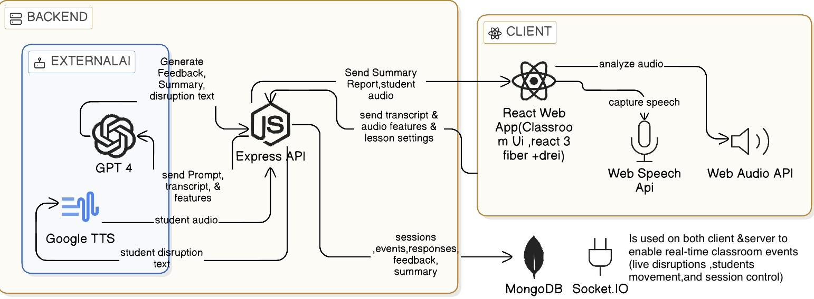

2.3 Activity diagram

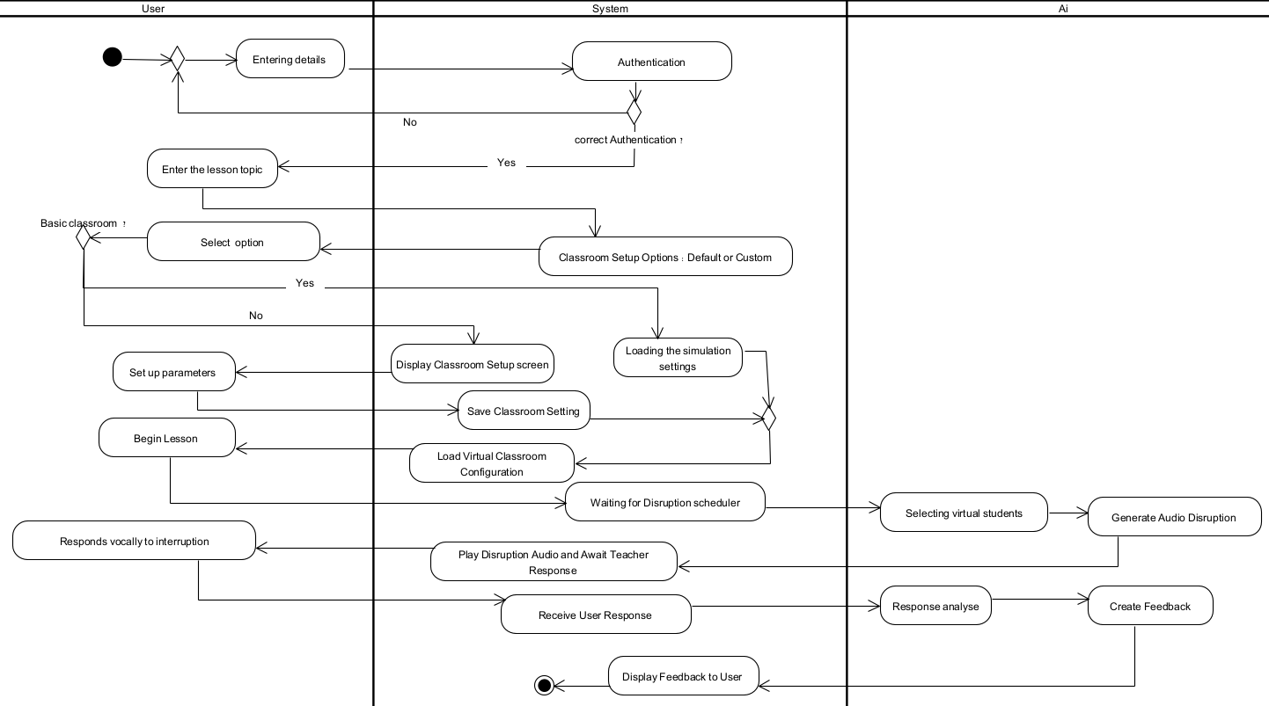

2.4 Project Achievements
The project successfully achieved the following outcomes:
- Development of a fully functional pedagogical classroom simulation system
- Integration of real-time interaction between teacher and virtual students
- Implementation of voice-based teacher input with Hebrew language support
- AI-driven analysis of teacher responses and classroom management strategies
- Generation of structured, meaningful feedback for reflective learning
- Deployment of both client and server on a cloud platform (Render)
- Creation of a modular architecture that supports future extensions

2.5 Deployment
The system is deployed using a cloud-based deployment model on the Render platform.
Both the client (frontend) and server (backend) are deployed under a single public domain.
The client application is served as a web application accessed through a browser, while the backend runs as a Node.js service that exposes REST APIs and WebSocket endpoints under the same domain.
The backend communicates securely with a remote MongoDB database.
This unified deployment approach simplifies configuration, avoids cross-origin issues, and ensures continuous availability, scalability, and ease of maintenance.

3 – Development Process
This chapter describes the development process of the Pedagogical Classroom Simulation System. It outlines the stages followed during implementation, the tools and technologies used, the challenges encountered, and the solutions adopted. In addition, the chapter evaluates whether the project goals were achieved and presents conclusions, lessons learned, and an assessment of compliance with the project success criteria.

3.1 Development Methodology and Critical Reflections
The Pedagogical Classroom Simulation System was developed using an agile and iterative development methodology, in direct continuation of the approach defined in Phase A. The development process was divided into short, recurring sprints, each dedicated to the implementation of a specific system component, its practical evaluation, and subsequent refinement based on both technological findings and pedagogical insights derived from system trials and hands-on use. This approach facilitated continuous system enhancement, preserved flexibility in decision-making, and supported the integration of additional capabilities as the project progressed.
Throughout the development process, the project was conducted in close collaboration with the system’s client, an experienced teacher and pedagogical instructor. Regular meetings were held at the end of development cycles, during which the client actively tested the system and provided pedagogical feedback based on authentic classroom experience. Two primary types of feedback were received. First, positive validation was expressed, with the client noting that the system reflected real classroom dynamics and describing the experience as the realization of a long-standing pedagogical vision. Second, constructive feedback focused on potential improvements, including a request to support additional languages (such as English and Arabic) and concerns regarding the initial visual appearance of the student avatars. Due to time and scope limitations, multi-language support could not be implemented within the project timeframe. In contrast, feedback regarding the visual design of the students was directly addressed: the development process evolved from initial reliance on external avatar-generation tools such as Ready Player Me toward a fully customized student avatar implementation using React Three Fiber, Three.js, and related libraries. This iterative refinement process continued until the visual representation aligned with the client’s pedagogical expectations.
Overall, the development process was conducted in a structured, efficient, and coordinated manner, and the agile methodology proved appropriate for the evolving nature of the project, which evolved and developed over time. Nevertheless, in retrospect, two aspects could have further improved the process. First, introducing a more structured experimentation phase earlier in the project for speech-processing and TTS components might have mitigated difficulties that later required repeated adjustments. Second, establishing a clearer and more measurable set of technological and pedagogical performance indicators at an earlier stage would have enabled a more systematic evaluation of simulation quality and feedback effectiveness across iterations.
Despite these considerations, the combination of an iterative development approach with continuous learning from system evaluations and user feedback ultimately contributed to the creation of a stable, functional system with clear pedagogical value

3.2 Tools and Technologies Used
The development relied on modern web technologies and cloud-based services.
Frontend tools:
- React for building the user interface
- React Three Fiber and Three.js for 3D
- Zustand
- React Router
- Axios
- Socket.IO
- Web Audio API and Web Speech API
Backend tools:
- Node.js with Express
- MongoDB with Mongoose
- Socket.IO
- JSON Web Tokens (JWT)
- OpenAI API (GPT)
- Google Text-to-Speech
- Nodemailer and Gmail OAuth2
- Node-Cron
Both the client and server were deployed on the Render cloud platform, enabling centralized deployment, scalability, and continuous availability.

3.3 Interaction with Stakeholders and Usability Evaluation
During development, the system’s design and functionality were guided by pedagogical considerations and continuous academic supervision. Feedback from the project supervisor informed system requirements, interface design, and the structure of feedback outputs, ensuring consistency between the technical implementation and the educational goals of the project.
System usability was evaluated using the System Usability Scale (SUS) questionnaire [7]. Prior to administering the questionnaire, several standard usability questionnaires and SUS-based instruments were reviewed [8] [9] [10]. Based on this review, a set of ten items was selected and adapted to best reflect the characteristics of the developed system and its intended users. The selected questions focus on core usability aspects commonly measured by SUS.
The questionnaire included statements such as the desire to use the system frequently, perceived ease of use and learnability, system consistency, confidence during use, and the extent to which technical assistance or learning effort was required. Together, these items provided a balanced assessment of both positive and negative usability perceptions, in line with standard SUS methodology.
Questionnaire Link.
The questionnaire was completed by the project’s client, a pedagogical mentor, after interacting with the virtual classroom simulation. The client also distributed the questionnaire to several teachers for additional evaluation. In addition, the development team distributed the questionnaire to early-career teachers within their professional network, who evaluated the system after using it.

3.4 Design Decisions and Justifications
Key design decisions included:
- Choosing a client–server architecture to support scalability and real-time interaction.
- Using web-based technologies to ensure accessibility without specialized hardware.
- Supporting Hebrew-only speech recognition to match the target educational context.
- Separating simulation logic, AI processing, and visualization to improve maintainability.
Each decision was guided by pedagogical relevance, technical feasibility, and long-term system sustainability.

3.5 Project Compliance with Defined Performance Indicators
The performance indicators established in Phase A addressed technological, pedagogical, and user-experience dimensions. In most of these areas, the system successfully meets the defined objectives.
From a technological standpoint, a dynamic simulation system was developed that incorporates speech processing, analysis of vocal characteristics, real-time generation of classroom disruptions, and the production of pedagogical feedback based on data collected throughout the simulation. From a pedagogical perspective, the system enables teachers to engage with complex classroom situations, interact with virtual students, and derive meaningful insights regarding their instructional behavior and classroom management strategies. Furthermore, considerable emphasis was placed on user experience, with the intention of creating a platform that is simple, intuitive, and accessible even for users without a technological background.
However, several indicators can still be further improved, particularly the accuracy of Hebrew speech transcription and the refinement of feedback quality so that it aligns more closely with established pedagogical standards. Nonetheless, in relation to the objectives originally defined, it can be concluded that the project successfully achieved its primary goals and was implemented in an effective and meaningful manner.

4 – Results
The developed system successfully meets the primary project goals by providing a realistic and interactive simulation environment in which teachers can practice classroom management, respond to disruptive behaviors, and receive structured pedagogical feedback. The integration of real-time interaction, voice-based input, and AI-driven analysis contributes to an immersive and pedagogically meaningful training experience.
Evaluation results collected through user questionnaires indicate a high level of usability and perceived effectiveness. The system achieved a high average SUS score of 85.9, reflecting very good overall usability. Beyond the SUS metric, additional questionnaire analysis shows that participants found the system easy to learn and use (average score 4.38/5), felt confident while using it (4.5/5), and perceived the system components as well integrated (4.5/5). Furthermore, respondents reported low levels of complexity, technical difficulty, and learning effort, suggesting that the system is accessible even for first-time users.
feedback from the post-development interview with Karen, a teacher and pedagogical mentor, further supports these findings. She described the system as fulfilling a long-standing professional dream and emphasized that the simulation realistically reflects the experience of new teachers in real classrooms. According to her feedback, the dynamically generated student interruptions create authentic classroom pressure, contributing to effective training. She also suggested future improvements, including extending support to additional languages and enhancing the feedback mechanism to explicitly highlight areas for improvement.
Overall, the results from the questionnaires and the interview show that simulation-based training can effectively bridge the gap between theoretical teacher preparation and real classroom practice, while providing meaningful, experience-driven pedagogical insights.

4.1 Evaluation Against Project Metrics
The system meets the success criteria defined in Phase A:
Test ID | Test Action | Expected Result | Actual Result | status
1 | Access the website URL | Page loads without errors | Loaded successfully | ✅
2 | Fill and submit registration form | New user is created | User created successfully | ✅
3 | Enter valid credentials | Redirect to dashboard | Login successful | ✅
4 | Click Start Simulation | Lesson settings screen opens | Opened successfully | ✅
5 | Enter topic, duration, level | Data is saved | Saved correctly | ✅
6 | Start simulation | 3D classroom loads | Loaded successfully | ✅
7 | View classroom | Students displayed | Displayed correctly | ✅
8 | Speak into microphone | Voice captured | Captured successfully | ✅
9 | Speak full sentence | Speech transcribed | Accurate transcription | ✅
10 | Speak quickly/softly | Reasonable transcription | Partial transcription | Partially Passed
11 | Teacher speaks during lesson | Disruption generated | Generated | ✅
12 | Disruption occurs | Student voice plays | Played successfully | ✅
13 | Teacher responds verbally | Response detected | Detected | ✅
14 | End interaction | Events saved | saved | ✅
15 | End simulation | Feedback displayed | Displayed | ✅
16 | Navigate screens | Fast loading | Fast | ✅
17 | Click Logout | Return to Home page | Completed | ✅
18 | User speaks Hebrew with noise | Accurate transcription | No Accurate transcription | ❌

Therefore, the project can be considered successful both technically and pedagogically.

5 – Conclusion and Future Work
This project aimed to bridge the gap between theoretical teacher preparation and real classroom practice by developing an interactive, simulation-based training system for classroom management. The developed system successfully achieved its core objectives by providing a realistic virtual classroom environment, dynamic AI-generated student behaviors, voice-based teacher interaction, and structured pedagogical feedback supported by AI analysis. The usability evaluation and qualitative feedback indicate that the system offers a meaningful and effective training experience, particularly for early-career teachers.
Despite these achievements, certain planned capabilities could not be fully implemented within the project scope. In particular, extending system support to additional languages (such as English and Arabic) and further expanding feedback personalization were identified as valuable enhancements but were constrained by time and resource limitations. These limitations point to clear directions for future work, including multilingual support, enriched feedback mechanisms, and broader evaluation with larger and more diverse user groups. Overall, the project demonstrates the potential of simulation-based training as a complementary tool in teacher education while providing a solid foundation for continued development and refinement.

6 – Challenges and Solutions
During the development of the Pedagogical Classroom Simulation System, several key challenges emerged regarding system behavior, real-time interaction, and management of simulation state. These challenges were identified through practical development work, continuous testing, and extensive use of the implemented functionality.
This section presents the main challenges encountered during development and the solutions that were implemented to effectively address them.

6.1 Defining Conditions for Generating Student Disruptions
Challenge: The disruption generation mechanism is based on the teacher’s speech during the simulation. Throughout development, it became evident that very short, initial, or fragmented teacher utterances triggered the disruption mechanism too early. This resulted in an unrealistic classroom flow and reduced the authenticity of classroom dynamics.
Solution: To address this issue, threshold conditions were introduced to ensure a minimum level of teacher speech and relevant teacher events before disruptions can be triggered. When these conditions are not met, the system refrains from generating disruptions and the simulation continues uninterrupted.

6.2 Hebrew Speech Processing and Transcription
Challenge: Since the system relies heavily on the teacher’s speech as a primary input, transcription accuracy is critical. Difficulties arose particularly with rapid speech, low volume, or frequent pausing, which sometimes led to inaccurate transcription. This, in turn, affected logging of events and activation of simulation logic.
Solution: The system currently employs a basic speech-to-text mechanism without advanced error correction or sophisticated acoustic analysis. To maintain stability, transcription is combined with straightforward logical validation, ensuring that partial or unreliable input does not activate key simulation processes incorrectly.

6.3 Session Isolation Between Simulations
Challenge: During testing, it was discovered that data from previous simulations (such as classroom events or the last recorded disruption) could unintentionally influence new simulations initiated by the same user.
Solution: A session isolation mechanism was implemented based on a unique simulation identifier. Upon starting a new simulation, relevant state data is reset, ensuring that each classroom session operates independently and is unaffected by previous runs.

6.4 Real-Time Event Synchronization
Challenge: The system must display student reactions and classroom events in real time. Maintaining synchronization between server-side state and the client-side visual classroom environment became challenging, particularly when multiple events occurred concurrently.
Solution: The system utilizes Socket.IO for real-time communication between server and client. This approach enables immediate state updates and seamless presentation of classroom activity without requiring page reloads.

6.5 Generating Meaningful and Pedagogically Relevant Feedback
Challenge: One of the core components of the system is the pedagogical feedback provided at the end of the simulation. During development, it became clear that producing feedback that is accurate, meaningful, and useful for teachers is a complex task. The feedback needed to avoid being overly generic, refrain from drawing incorrect conclusions based on partial data, and remain clear, realistic, and relevant to authentic classroom situations. In addition, an appropriate method had to be designed for integrating speech transcription, teacher vocal characteristics, and student disruption events into a coherent and reliable feedback process.
Solution: The feedback mechanism was designed to aggregate data from multiple components simultaneously, including teacher speech transcription, vocal attributes (such as volume and tone), and the temporal sequence of classroom disruptions. These data elements undergo processing and are then analyzed using GPT-based pedagogical reasoning. The output is subsequently filtered and validated on the server side to prevent inaccurate, irrelevant, or weakly supported conclusions. Through this approach, the system produces focused, readable, and contextually relevant feedback that helps teachers understand their classroom management behavior and identify clear areas for improvement.

References
1.Dicke, T., Parker, P. D., Holzberger, D., Kunina-Habenicht, O., Kunter, M., & Leutner, D. (2015). Beginning teachers’ efficacy and emotional exhaustion: Latent changes, reciprocity, and the influence of professional knowledge. Contemporary Educational Psychology, 41, 62–72. https://doi.org/10.1016/j.cedpsych.2014.11.003

2.Gourneau, B. (2014). Challenges in the first year of teaching: Lessons learned in an elementary education resident teacher program. Contemporary Issues in Education Research, 7(4), 299–316 - https://files.eric.ed.gov/fulltext/EJ1073282.pdf
3. Ingersoll, R. M. (2003). Is there really a teacher shortage? Center for the Study of Teaching and Policy, University of Washington. https://repository.upenn.edu/gse_pubs/133
4. Vasquez, A. C., & Tournaki, N. (2024). The effects of a behavioral intervention program on early-career teachers' classroom management skills. Early Childhood Research Quarterly.
https://www.sciencedirect.com/science/article/abs/pii/S0272775724000931
5. Israeli Ministry of Education National Report 2023 — Classroom Management Challenges Among New Teachers https://edu.gov.il/ministry/reports/2023-classroom-management-report

6. Central Bureau of Statistics (CBS) Report 2022 — Trends in Teacher Burnout and Workload in Israel
https://www.cbs.gov.il/en/mediarelease/Pages/2022/teacher-burnout-and-workload.aspx

7.System usability scale. (n.d.). In Wikipedia. https://en.wikipedia.org/wiki/System_usability_scale
8.Thakar, S. (2021, September 11). System Usability Scale (SUS) explained. Medium. https://medium.com/design-bootcamp/system-usability-scale-explained-5f98dcf4a740
9.SurveyLab. (n.d.). System usability scale (SUS). https://www.surveylab.com/blog/system-usability-scale-sus/
10.QuestionPro. (n.d.). System usability scale survey questions template. https://www.questionpro.com/survey-templates/system-usability-scale-survey-questions-template/
11. SimSchool. (n.d.). SimSchool: Simulated classroom environment for teacher preparation. Retrieved [Month Day, Year], from https://www.simschool.org/landing/



Software Engineering Department
Braude - College of Engineering
Capstone Project Phase B – 61999

Pedagogical Training
Project code: 25-2-D-17
Supervisor:
Dr. Natali Levi-Soskin

User Guide

Authors:
Celin Asadi 324300706
Anood Naem 324222553

Github link :
https://github.com/CelineAsadi/Pedagogical-Training-project.git
video Tutorial : How to use our website (5:58min)
tutorial.mp4

VIDEO TUTORIAL (SHORTER VERSION 2:00 MIN )
VIDEO-2026-01-28-12-23-44.mp4

Table Of Contents
Table Of Contents 22
Introduction 23
Requirements 24
Flow Of The System 24
Home Screen 24
Contact 25
Signup 26
Login 27
Forgot Password 27
Main Simulation 28
Profile 30
My Simulation 31
Standard Virtual Classroom Simulation 32
Set Up Virtual Classroom Simulation 34
Feedback Summary 35
Logout 37

Introduction
This guide provides a comprehensive explanation of the Pedagogical Classroom Simulation System, an interactive application designed to support teachers in developing effective classroom management and pedagogical skills.
The guide explains how users can operate the system, interact with the virtual classroom, respond to student disruptions, and receive meaningful feedback on their performance. It describes the operational flow of the system from the beginning of a simulated lesson to the generation of a final performance summary. The system supports two types of classrooms: a standard classroom and a customized classroom, allowing flexibility in training scenarios.
The guide focuses on the successful usage flow of the system and is intended to help users understand how to operate the application in a smooth and effective manner.

Requirements
To use the system, users need a computer with a working microphone and a stable internet connection.
The system runs in a web browser, with Google Chrome recommended.
An active Gmail account is required for registration and login.
Teacher voice input must be provided in Hebrew, as the system currently supports Hebrew speech only.

Flow Of The System

Home Screen
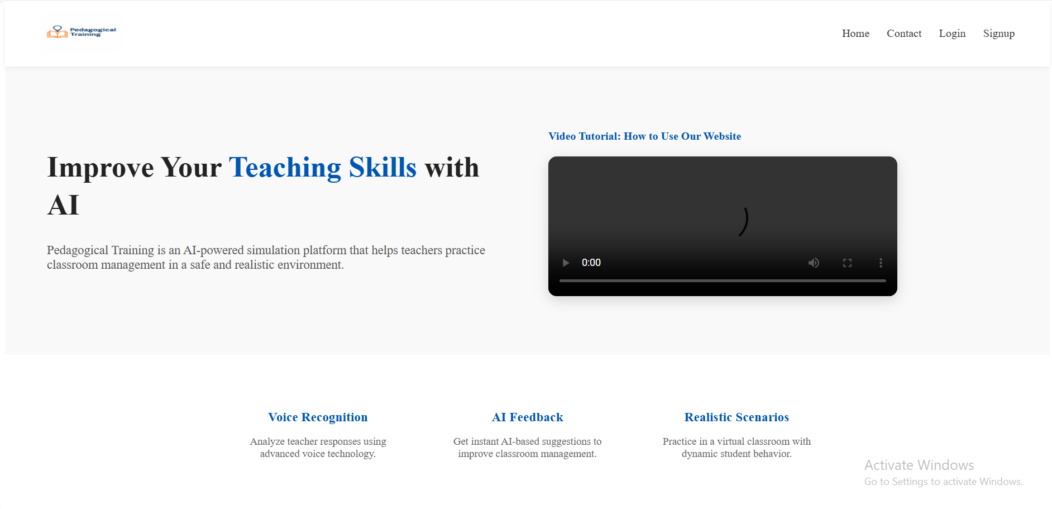
When users first access the Pedagogical Training platform, they are presented with the Home Screen.
This screen provides a high-level overview of the system and introduces its main purpose:
to help teachers improve their classroom management skills through AI-powered simulation.
From this screen, users can understand what the system offers and navigate to the relevant sections in order to begin using the platform.
This screen is the entry point for all users and allows them to sign up, log in, watch the introduction video, or contact the system.

Contact
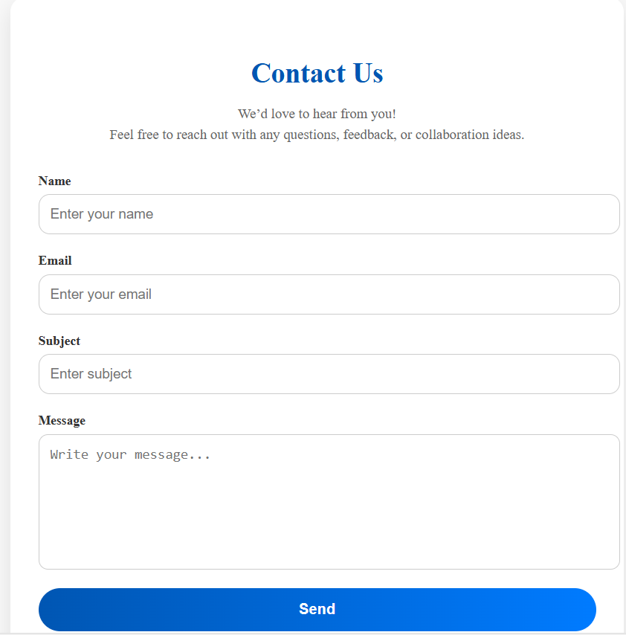
The Contact Us page allows users to communicate with the system administrators.
The user can submit:
- Name
- Email
- Subject
- Message
This page is intended for questions, feedback, or collaboration requests.

Signup
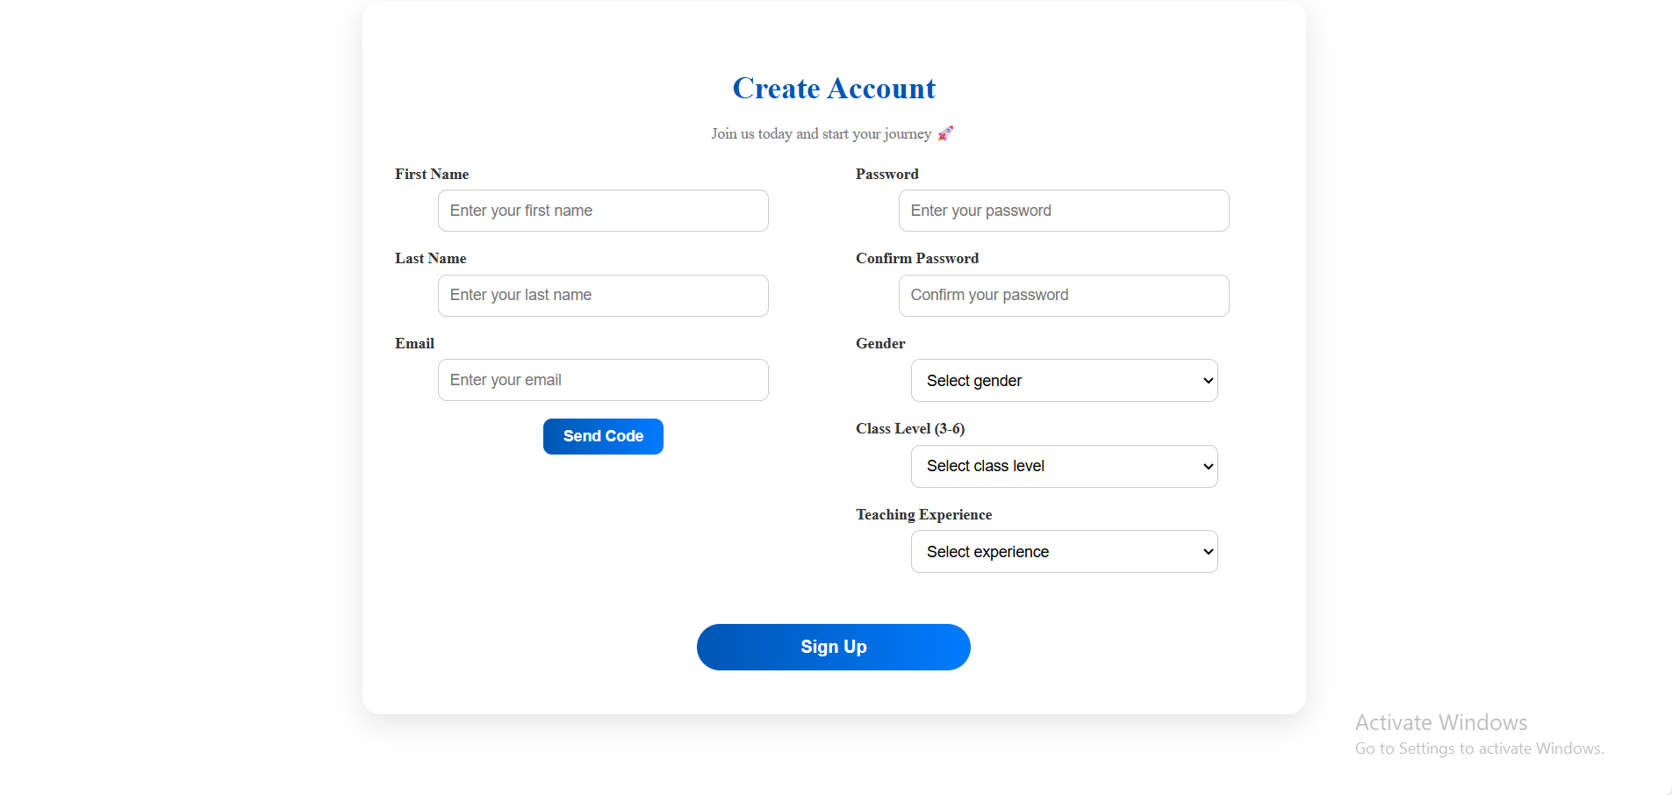
To begin using the Pedagogical Training system, users must first create a personal account by clicking in the Home Screen on the sign up button.
On the Create Account screen, the user is required to provide the following information:
- First Name and Last Name
- Email Address (a valid Gmail account is required)
- Password and Confirm Password
- Gender
- Class Level (grades 3–6)
- Teaching Experience (0-5+)
After entering the email address, the user clicks Send Code to receive a verification code via email.
Once the code is received and verified, the user completes the remaining fields and clicks Sign Up.
Upon successful registration, the account is created automatically, and the user is redirected to the Main Simulation Page, where they can immediately start using the system.

Login
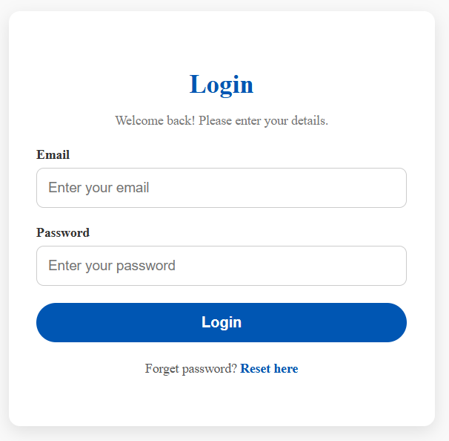
Registered users can access the system by selecting Login from the Home Screen.
To log in, the user must enter:
- Email address
- Password
After clicking the Login button, the system authenticates the credentials.
If the login is successful, the user is redirected to the Main Simulation Page and can start using the system immediately.
In case the user forgets their password, a Reset Password option is available.

Forgot Password
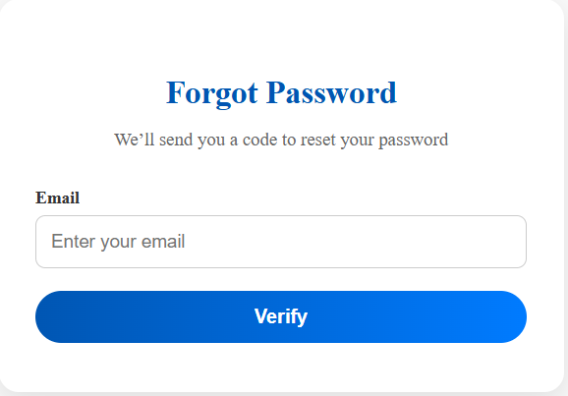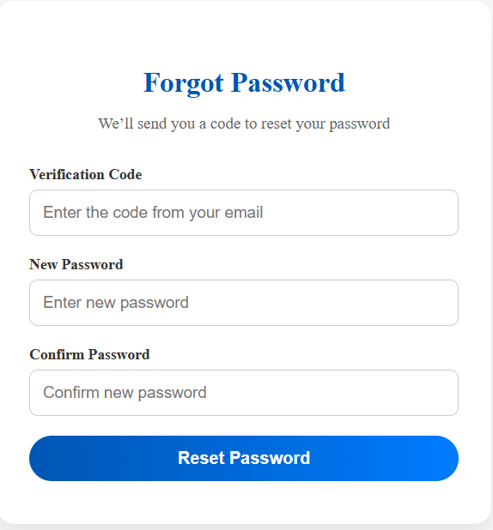
If a user forgets their password, the system provides a secure recovery process.
- On the Login page, click Forgot password? Reset here.
- Enter the registered email address and click Verify.
- A verification code is sent to the user’s email.
- Enter the verification code, choose a new password, and confirm it.
- Click Reset Password.
After a successful password reset, the user is redirected back to the Login page and can sign in using the new password.

Main Simulation
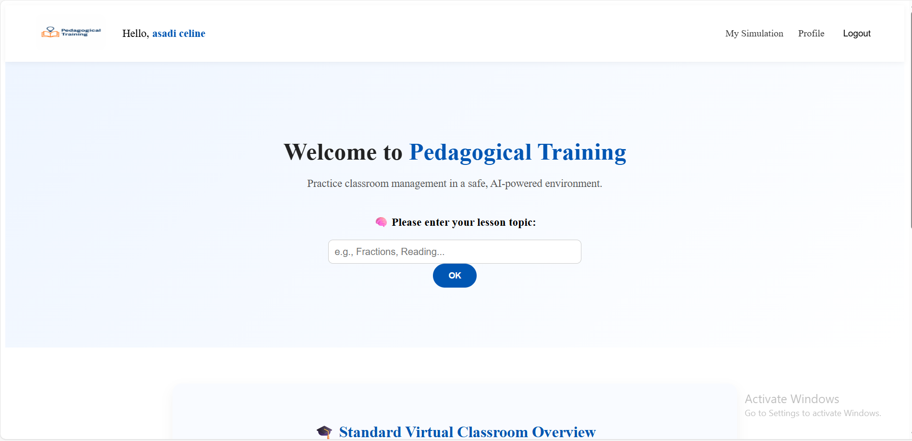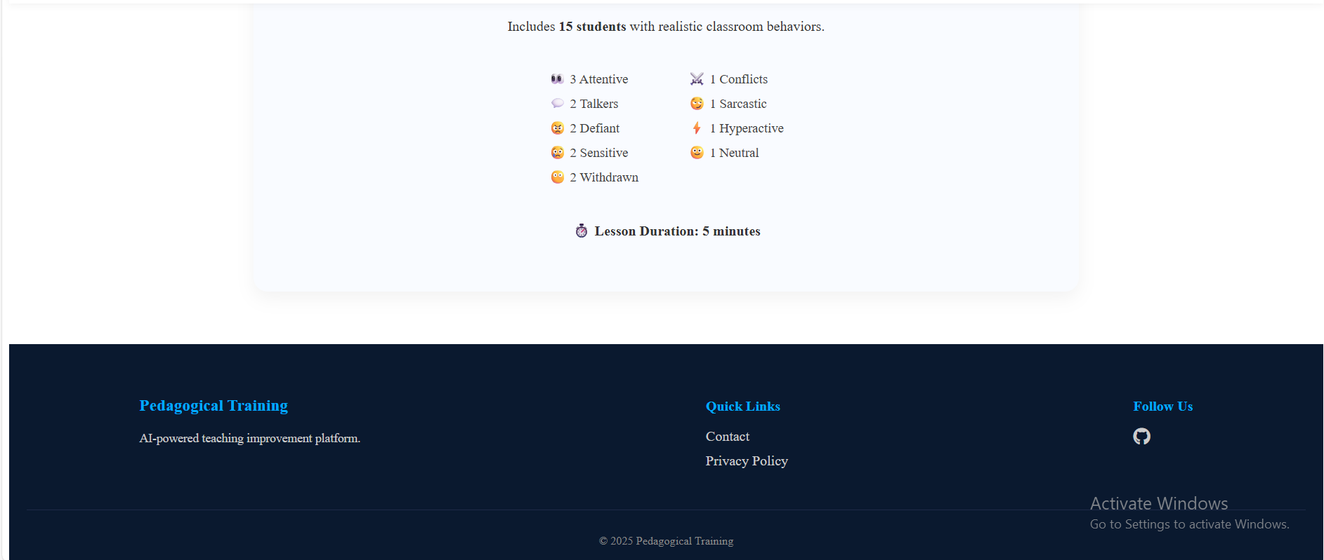

After a successful login, the user is directed to the Main Simulation Page, which serves as the central hub of the system.
Top Navigation Bar
At the top of the screen, the user can access the following options:
- Profile
Allows the user to view and update personal information .
- My Simulations
Displays a history of all previous simulations.
- Logout
Logs the user out of the system and returns them to the Home Page.
Main Simulation Area
In the main section of the page, the user can perform the following actions:
- Enter a Lesson Topic
The teacher provides the subject of the lesson (for example: Math, Reading, Grammar).
- View Standard Classroom Information
The system displays information about the default classroom setup, including the number of students, behavior types, and lesson duration.
Classroom Selection
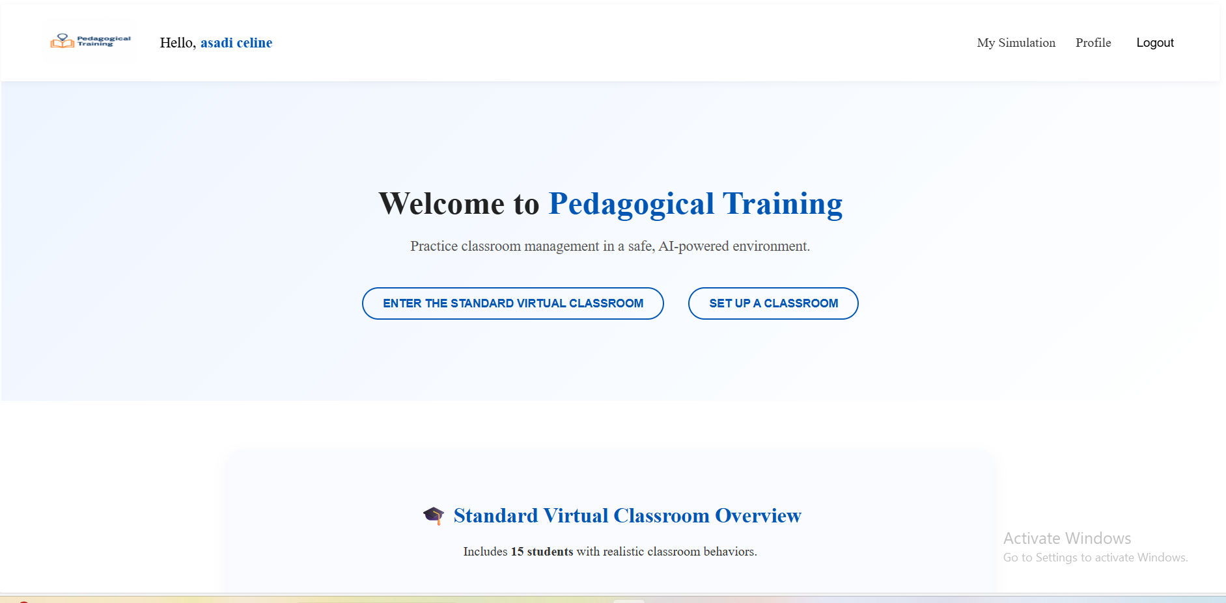
After entering the lesson topic and clicking the OK button, two options appear:
- Enter the Standard Virtual Classroom
Starts a simulation using the predefined classroom configuration.
- Set Up a Classroom
Allows the user to customize the classroom setup before starting the simulation.
The user selects one of these options to begin the teaching simulation.

Profile
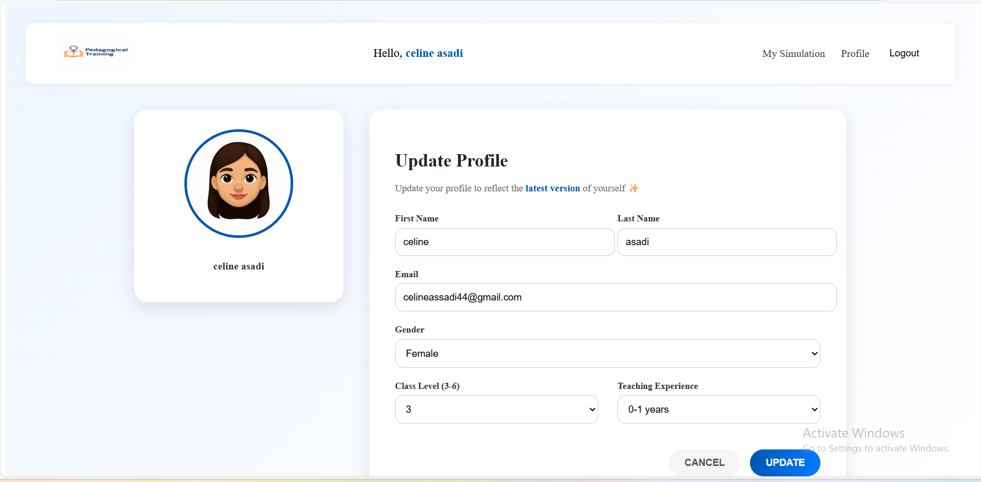When the user clicks the Profile button in the Top Navigation Bar of the Main Simulation Page, the system navigates to the Profile Page.
The Profile Page allows the user to view and update personal information.
This information is used by the system to personalize the simulation experience and adapt classroom scenarios to the teacher’s background.
The profile includes the following fields:
- First Name
- Last Name
- Email Address
- Gender
- Class Level
- Teaching Experience
After making the desired changes, the user can click the Update button to save the information.
The updated profile data is applied to future simulations and influences classroom behavior, student responses, and feedback generation.
This page enables users to keep their personal and professional details up to date, ensuring a more accurate and personalized training experience.

My Simulation
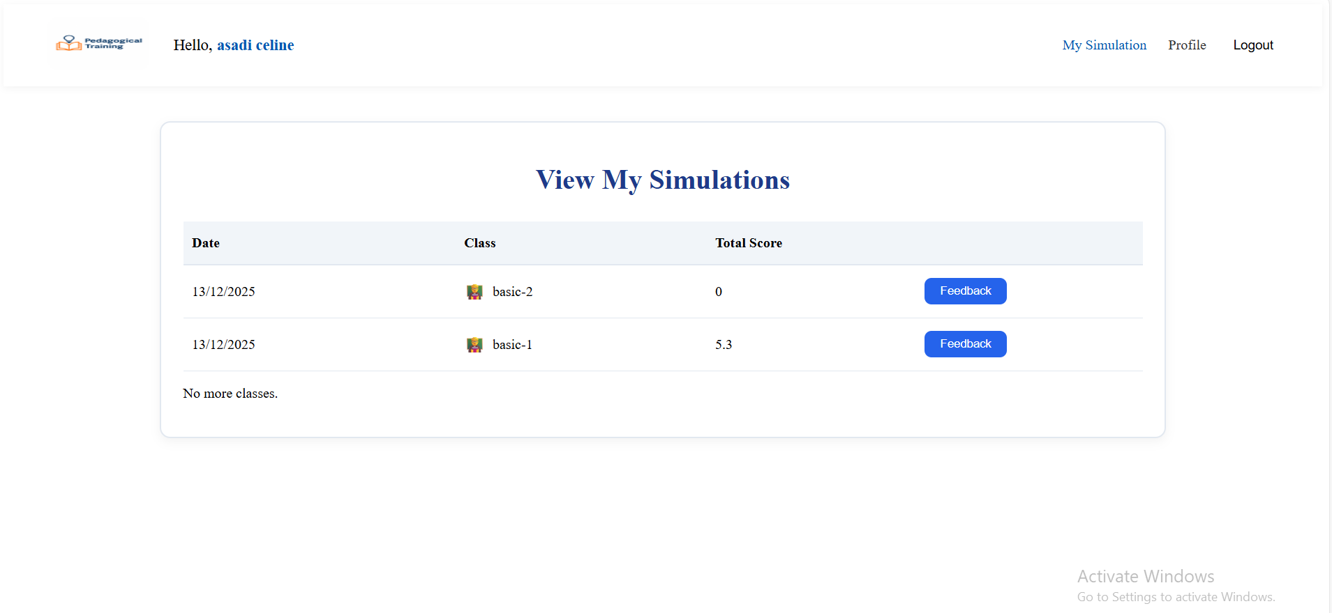
When the user clicks on My Simulation in the top navigation bar of the Main Simulation Page, the system displays a history of all previously completed simulations.
For each simulation, the following information is shown:
- Simulation Date – the date on which the session was conducted
- Classroom Type – either the standard classroom (Basic) or a custom classroom defined by the user
- Total Score – the overall performance score achieved in the simulation
- Feedback Access – a button to view detailed session feedback
By clicking the Feedback button, the user can review the full session summary, including:
- Performance scores
- Strengths
- Weaknesses
- Comparison between this simulation and previous years
This page allows users to track their progress over time, compare past simulations, and reflect on their teaching performance in order to improve classroom management skills.

Standard Virtual Classroom Simulation
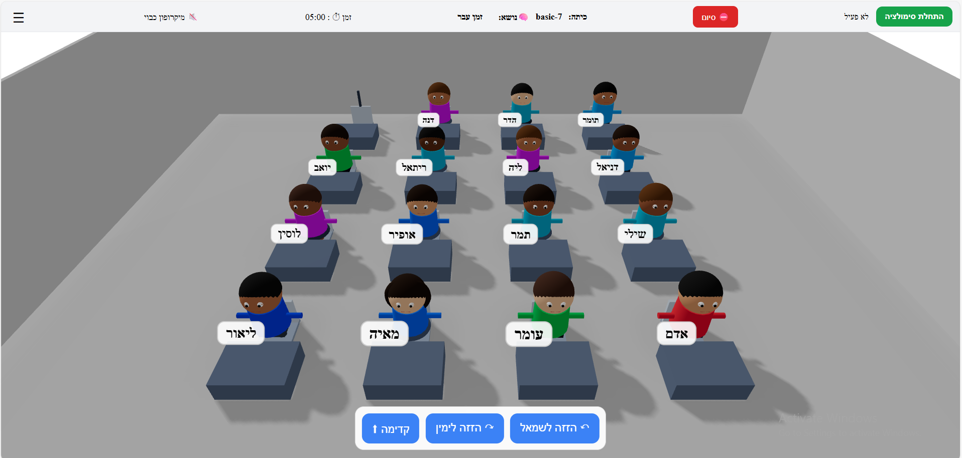
When the user selects Enter the Standard Virtual Classroom in the Main Simulation Page, the simulation screen appears.
In this screen:
- The virtual classroom is displayed with student avatars.
- Each student has a predefined behavior profile.
- The top bar shows:
  - Simulation start and end buttons ( כפתורי התחלה וסיום של הסימולציה )
  - Lesson topic (נושא השיעור)
  - Class name (שם הכיתה)
  - Lesson duration (משך השיעור)
  - Microphone status (סטטוס המיקרופון)
In the top-right corner of the screen, there is a menu icon (three horizontal lines).
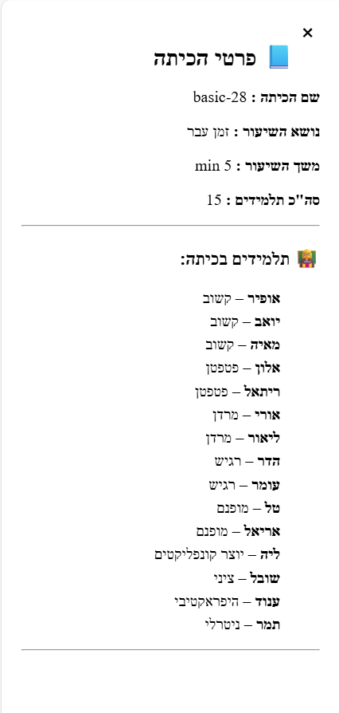
When the user clicks this icon, a side panel opens displaying detailed classroom information, including:
- Class name (שם הכיתה)
- Lesson topic (נושא השיעור)
- Lesson duration (משך השיעור)
- Total number of students ( רשימת תלמידים וסוגי התנהגותם)
This panel helps the teacher understand the classroom composition during the simulation.
In addition, you can freely drag students, desks, and chairs across the classroom, and rotate them:
Forward , Move Left, Move Right (קדימה , הזזה לשמאל והזזה לימין )

Starting the Simulation
The user can start the simulation by clicking Simulation start button (התחלת סימולציה) , interact verbally, and manage classroom behavior in real time.
Ending the Simulation
The simulation ends in one of two ways:
- The teacher clicks Simulation End button (סיום) button.
- The session timer reaches zero.
In both cases:
- The simulation stops.
- Student audio and interactions are terminated.
- A feedback summary is generated automatically.
The user is then redirected to the feedback view, where performance scores, strengths, and weaknesses are presented.

Set Up Virtual Classroom Simulation
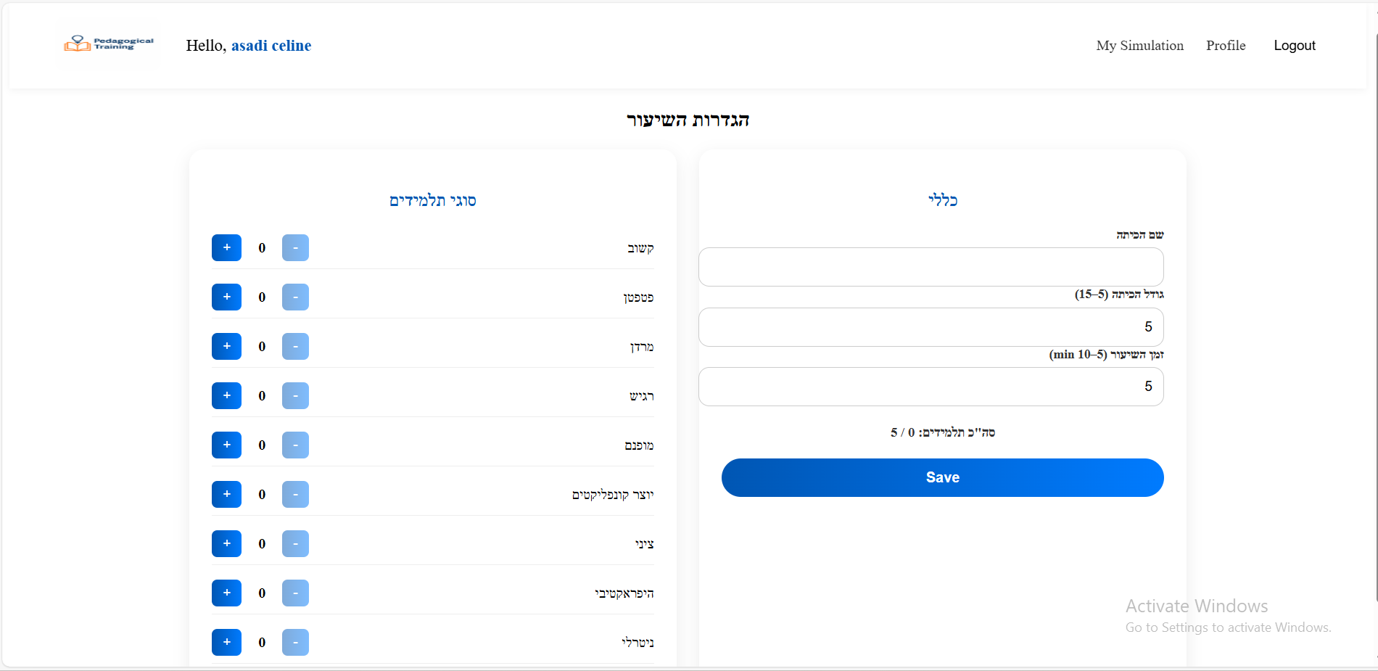When the user selects Enter the Set Up Virtual Classroom in the Main Simulation Page, the set up simulation screen appears.
The user can define:
- Class name (שם הכיתה)
- Class size (5–15 students) (גודל הכיתה)
- Lesson duration (5–10 minutes) (זמן השיעור)
- Number of students by behavior type (מספר תלמידים לפי סוג התנהגות)
  - Attentive (קשוב)
  - Talkative (פטפטן)
  - Defiant (מרדן)
  - Sensitive (רגיש)
  - Introverted (מופנם)
  - Creates conflicts (יוצר קונפליקטים)
  - Sarcastic (ציני)
  - Hyperactive (היפראקטיבי)
  - Neutral (ניטרלי)
After clicking Save Settings, the customized classroom is created.
The simulation then starts with the selected parameters, using the same simulation interface as the standard classroom.

Feedback Summary
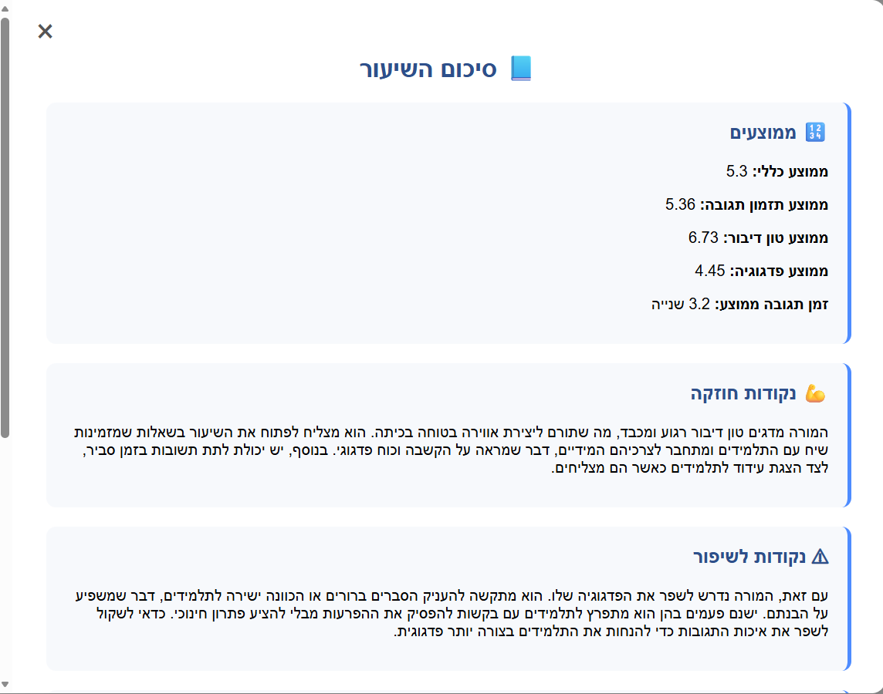
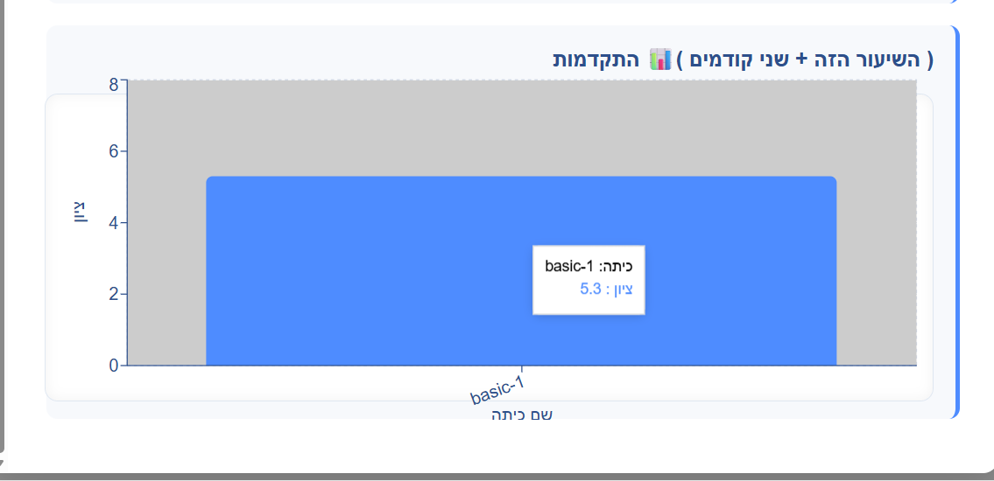
There are two ways to view feedback:
1. Immediate Feedback After Simulation Ends
When the simulation ends, the system automatically generates a session summary and displays the feedback.
2. Feedback from “My Simulations”
The user can later access feedback by navigating to My Simulations and clicking the Feedback button for a specific session.
Types of Feedback:
Meaningful Feedback
If the teacher interacted verbally during the simulation:
- Performance scores are calculated
- Strengths and weaknesses are identified
- Pedagogical, timing, tone, and response metrics are shown
No Interaction Feedback
If the teacher did not provide any verbal responses during the lesson:
- All performance scores are set to 0
- No strengths are displayed
- A note appears in the weaknesses section indicating that evaluation was not possible:
“No teacher response was provided during the lesson, so performance cannot be evaluated.” (לא נמסרו תגובות מורה במהלך השיעור ולכן לא ניתן להעריך ביצועים)

Logout
Clicking Logout ends the current session and returns the user to the Home Page.



Software Engineering Department
Braude - College of Engineering
Capstone Project Phase B – 61999

Pedagogical Training
Project code: 25-2-D-17
Supervisor:
Dr. Natali Levi-Soskin

Maintenance Guide

Authors:
Celin Asadi 324300706
Anood Naem 324222553

Github link :

https://github.com/CelineAsadi/Pedagogical-Training-project.git

Table Of Contents
Table Of Contents 39
Introduction 40
System Architecture 40
System Components 40
Software Dependencies 40
Client 40
Server 41
Code Structure 41
Client Side 41
Components Folder 42
Hooks Folder 43
Lib Folder 44
Store Folder (Zustand State Management) 46
Style Folder 47
Entry Files 48
Server Side 49
Controllers Layer (controllers) 51
Models Layer (models) 52
Routes Layer (routes) 52
Services and AI Logic (services & logic) 53
Real-Time Communication (socket) 54
Utilities and Infrastructure (lib) 54
Installation and Setup Instructions 56
Token and Credential Management 56
Monitoring and Logging 57

Introduction
This maintenance guide is intended for developers and engineers responsible for maintaining, updating, and extending the Pedagogical Classroom Simulation System after project completion.
The guide describes the system architecture, software dependencies, and code structure, and provides essential information for implementing updates, fixing issues, and ensuring long-term system stability.

System Architecture
The system is based on a client–server architecture, enabling real-time interaction, voice-based interaction, AI-based analysis, and feedback generation.

System Components
- Client (React-based web application)
- Server (Node.js + Express backend)
- MongoDB database
- Real-time communication via Socket.IO
- External AI and Google services

Software Dependencies

Client
The client side is a web-based application built with React and runs in a modern browser.
Required environment:
- Operating System: Windows / macOS / Linux
- Web Browser: Google Chrome (recommended)
- Node.js (for development and build)
Main technologies used:
- React (UI framework)
- React Router (navigation)
- Zustand (state management)
- Web Speech API (capture speech and transcript)
- Web Audio API (analyze )
- Socket.IO Client (real-time communication)
- Three.js + React Three Fiber (3D classroom rendering)
- Recharts / Chart.js (data visualization)
- Axios (HTTP communication)
- ReactDOM is a library in React that connects React components to the browser’s DOM.

Server
The backend is implemented using Node.js and Express, and is responsible for session management, real-time simulation logic, AI integration, and data persistence.
Required environment:
- Node.js runtime
- MongoDB database (cloud or local)
- Internet connection (for OpenAI, Google APIs, and OAuth services)
Main technologies used:
- Express (API server)
- Socket.IO (real-time communication)
- MongoDB + Mongoose (database)
- OpenAI API (AI-based summary , disruption and feedback)
- Google Text-to-Speech (student voice generation)
- Google OAuth2 (authentication)
- JWT (session and token handling)
- Node-Cron (scheduled tasks)

Code Structure
This section provides an overview of the system codebase structure. It is intended to help maintainers understand the organization of the project, identify key components, and perform future updates, fixes, or extensions efficiently.

Client Side
The client is responsible for user interaction, UI rendering, real-time classroom visualization, and communication with the backend services.
The main client directory is located under:
client/src

Components Folder
The components folder contains all React components that represent application screens and core UI elements.
Key components include:
- Home.jsx
The landing page after login. Allows the user to enter a lesson topic and choose between a standard classroom or a custom classroom.
- Signup.jsx / Login.jsx / Forgetpassword.jsx
Handle user authentication, registration, and password recovery flows.
- MainPage.jsx
Acts as the main simulation hub and navigation point after authentication.
- VirtualClassroom.jsx
Responsible for rendering the virtual classroom environment.
- VirtualClassroomCore.jsx
The core simulation engine handles: Lesson timing ,Student behavior events ,Teacher speech handling , Real-time interactions via Socket.IO ,Simulation start/end logic
Main Functions and Core Handlers:
handleTeacherFinalUtterance(teacherText, meta) _ Processes the finalized teacher speech input, attaches voice analysis features,links the response to the latest student disruption, and sends it to the backend.
useEffect (socket initialization and disruption listener) _ Initializes the Socket.IO connection for the active session and listens for AI-generated student disruption events from the backend.
handleStart() _ Starts the lesson simulation by sending student data to the backend, requesting microphone access, starting the lesson timer, and emitting lesson:start.
handleStop() _ Stops the lesson simulation, cleans up socket and audio resources, requests AI-generated session summary, and navigates back to the main page.
- LessonSettings.jsx
Enables users to configure a custom classroom (class size, duration, student behavior types).
- MySimulations.jsx
Displays the history of completed simulations and provides access to feedback summaries.
- Profile.jsx
Allows users to view and update personal information used to personalize simulations.
- Summary Popup.jsx
Displays post-lesson feedback including scores, strengths, and weaknesses.
- Student Avatar.jsx
Represents individual students inside the 3D classroom, including visual state and speaking indicators.
- Contact.jsx / PrivacyPolicy.jsx
Static informational pages for user communication and legal information.

Hooks Folder
This section describes the custom React hooks used in the client side of the Pedagogical Classroom Simulation System.
These hooks encapsulate core logic related to classroom configuration, teacher speech recognition, and voice analysis, enabling modularity, reusability, and easier maintenance.

useClassroomConfig.Js :
The useClassroomConfig hook prepares the virtual classroom configuration before the simulation starts Supports default and customized classrooms while generating and validating students and lesson data Stores the classroom state globally and ensures readiness before rendering
Main Functions:
fetchConfig() _ Loads lesson settings from the backend by className and falls back to a default classroom configuration if none exists.
getUniqueName(list)_ Selects and removes a unique student name from the given name pool.
useEffect (classroom initialization) _ Initializes the classroom before the simulation by generating students, assigning seats, updating the global classroom store, and exposing a loading state.

useTeacherSpeechRecognition.Js :
The useTeacherSpeechRecognition hook handles real-time Hebrew speech recognition for the teacher during the simulation Applies fallback handling, optional audio analysis, automatic restart, and safe cleanup to ensure reliable teacher input.
Main Functions:
useEffect (SpeechRecognition initialization) _ Initializes the browser SpeechRecognition engine, configures language, and handles auto-restart when recognition stops unexpectedly.
recognition.onresult _Processes interim and final speech recognition results and forwards them to the relevant callbacks.
useEffect (fallback interim → final) _ Converts long interim speech into a final utterance after a silence threshold.
useEffect (start / stop recognition) _ Starts or stops speech recognition based on the enabled flag.
useEffect (audio feature extraction)_ Captures microphone audio and extracts basic voice features (volume and pitch).

useTeacherVoiceAnalysis.Js :
The useTeacherVoiceAnalysis hook analyzes the teacher’s voice during the simulation, extracts stable voice features for feedback and performance evaluation while safely managing audio resources
Main Functions:
analyzeFrame(buffer, sampleRate) _ Analyzes raw audio frames to extract volume (RMS) and pitch.
estimateTone(volume, pitch) _ Maps volume and pitch values to a pedagogical tone classification such as : Calm, Neutral, Firm, Stressed, Loud, Angry.
useEffect (voice analysis lifecycle) _ Starts and stops real-time microphone analysis based on the enabled flag, updates voice features continuously during active simulation, and cleans up audio resources when analysis ends.

Lib Folder
The client/src/lib folder contains shared utilities that are used across multiple screens and components (networking, sockets, 3D interactions, TTS, and global state).

axios.js — API HTTP Client
This file creates a single axiosInstance used for all REST API calls.
- Automatically selects the backend URL.
- Uses withCredentials: true so cookies/session authentication can work correctly.

socket.js — Real-Time Connection (Socket.IO)
This file exports createSocket(sessionId) to connect the client to the backend via Socket.IO for real-time simulation events (e.g., disruptions).
- Automatically selects backend URL.
- Uses: withCredentials: true,transports: ["websocket"] (important for stable behavior on Render)

drag.js — 3D Drag Helpers
This file contains utilities for interacting with the classroom floor in the 3D scene.
Main Functions:
clampToRoom()_ keeps dragged objects inside classroom boundaries.
snapVec3()_ snaps positions to a grid using SNAP.translate for consistent placement.
useDragOnFloor()_ converts pointer events into 3D world coordinates using a raycaster and a floor plane.

ttsClient.js — Student Text-to-Speech (TTS)
This file manages student voice output by requesting audio from the server and playing it in the browser.
Main Functions:
fetchTtsAudio() sends a request to /api/tts/speak and receives Base64 MP3.
playTTSAudio() plays the audio immediately using the browser Audio API.

voiceRuntime.js — Instant Speech Bubble Runtime (No React State)
This file holds an in-memory registry of which student is “currently speaking”, to show speech bubbles instantly.
Main Functions:
setSpeaking(studentId, text) _ show bubble immediately
clearSpeaking(studentId) _ hide bubble
subscribeToSpeakingMap(cb) _UI components subscribe to changes without waiting for React store updates

store/index.js — Global Classroom State (Zustand)
This is the main state store for the classroom simulation and 3D layout
Manages the classroom layout, simulation runtime data, and shared state for items, students, disruptions, and teacher responses
Builds a default classroom layout automatically and keeps all lesson-related state centralized
Main Functions / Actions:
buildClassItems() – Generates the default classroom layout by creating desks and chairs in organized rows
startDisruption() – Adds a new disruption event and updates the last active disruption
endDisruption() – Marks the current disruption as ended
addTeacherResponse() – Stores teacher response events, including text and optional voice features
clearDisruptions() – Resets all disruptions and related runtime data at the end of a lesson

Store Folder (Zustand State Management)
The store folder contains all global state management logic for the client-side application, implemented using Zustand. It is a lightweight and efficient state management library that enables shared state across components without prop drilling.Each store is responsible for a specific domain of the system, such as authentication, lesson management, simulations, and user support. This modular structure improves maintainability, scalability, and code clarity.

authStore.js:
The authentication store manages user authentication state and related actions throughout the application.
Key responsibilities include:
Storing the currently authenticated user (authUser).
Checking authentication status on page refresh.
Handling login, logout, and signup flows.
Managing password reset and email verification.
Updating user profile information.

lessonSettingsStore.js:
This store manages custom lesson and classroom configuration before starting a simulation.
Key responsibilities include:
Saving lesson settings to the backend
Retrieves authenticated user information.
Creating a lesson entry
Starting a simulation session
Generating the correct classroom URL for navigation

mainPageStore.js:
The main page store controls logic related to the main simulation dashboard and lesson history.
Main functions:
fetchUser() – Retrieves current user information.
startBasicLesson() – Creates a standard lesson and starts a session.
fetchUserClasses() – Retrieves paginated lesson history.
fetchClassSummaries() – Fetches lesson details with session summaries.
fetchLastThree() – Retrieves the last three feedback entries for a session.

supportStore.js:
The support store handles communication between users and system administrators via the Contact Us form.
Main function:
contactUs – Sends support messages and confirms successful submission using notifications.

Style Folder
The style folder contains CSS files for individual components.
Each main component has a corresponding CSS file, for example:
- Login.css
- Signup.css
- VirtualClassroom.css
- VirtualClassroomCore.css
- SummaryPopup.css
This approach maintains visual consistency and simplifies UI updates.

Entry Files

App.js – Application Routing and Access Control
The App.js file defines the main structure, routing logic, and access control mechanism of the Pedagogical Classroom Simulation System on the client side.
Public Routes
The following routes are accessible without authentication:
Home (/) – Entry screen with general system information.
Login (/Login) – User login page.
Signup (/Signup) – User registration page.
Forget Password (/Forgetpassword) – Password recovery process.
Contact (/Contact) – Contact and support form.
Privacy Policy (/PrivacyPolicy) – Legal and privacy information.
If an authenticated user attempts to access these routes, they are automatically redirected to the Main Simulation Page.
Protected Routes
The following routes are available only to authenticated users:
MainPage (/MainPage) – Central hub for starting simulations.
Profile (/Profile) – User profile management.
My Simulations (/MySimulations) – History of completed simulations and feedback.
Lesson Settings (/LessonSettings) – Custom classroom configuration.
Virtual Classroom (/VirtualClassroom) – The active classroom simulation environment.
If an unauthenticated user attempts to access any protected route, they are redirected to the Home page.
Notifications
The application integrates react-hot-toast via the <Toaster /> component to display real-time feedback messages such as login success, errors, and system notifications.
Fallback Route
A wildcard route (*) is defined to catch any invalid URLs and redirect users back to the Home page, preventing broken navigation paths.

index.js – Application Entry Point
This file ensures that the application is mounted correctly to the DOM and provides a stable foundation for rendering the entire client-side system.

Client .env Variables
- REACT_APP_SERVER_URL
Base URL of the backend server used by the frontend for API requests.

Server Side
The server-side of the Pedagogical Classroom Simulation System is responsible for managing authentication, lesson and session logic, real-time classroom events, AI-driven analysis, feedback generation, and communication with external services.
Server Structure Overview
The server code is organized under the src directory and divided into logical layers, each with a specific responsibility:
- Controllers – Handle HTTP requests and responses
- Routes – Define API endpoints and route requests
- Models – Define database schemas
- Services / Logic – Contain business logic and AI-related processing
- Middleware – Handle authentication and request validation
- Socket Layer – Manage real-time classroom events
- Configuration & Utilities – External services, helpers, and infrastructure logic
This separation ensures clean code boundaries and simplifies future extensions.

Configuration (config)

tts-service-account.json
This file contains Google Cloud Text-to-Speech credentials used to generate synthetic student voices during the simulation
Enables realistic and differentiated student speech based on gender and behavioral profiles
Value: "service_account"
Specifies that this JSON file represents a Google Service Account.
Service accounts are used for server-to-server authentication without user interaction.
Value: project_id
The Google Cloud Project ID where the Text-to-Speech service is enabled.
All API usage, billing, and permissions are associated with this project.
Value:private_key_id
A unique identifier for the private key.
Used internally by Google to track and validate which key is being used for authentication.
Value:private_key
The cryptographic private key used to sign authentication tokens.
This key proves that your server is authorized to access Google APIs.
Value:Security Note
This field must be kept strictly secret and must never be exposed to the client or committed to a public repository.
Value:client_email
The email address of the service account.
This identity is used by your backend when authenticating to Google Text-to-Speech APIs.
Value:client_id
A unique numeric identifier for the service account.
Used internally by Google OAuth systems.
Value:auth_uri
The OAuth 2.0 authorization endpoint used by Google.
This URL is part of the authentication flow for generating access tokens.
Value:token_uri
The OAuth 2.0 token endpoint.
Your backend exchanges signed credentials here to receive short-lived access tokens for API calls.
Value:auth_provider_x509_cert_url
A URL pointing to Google’s public certificates used to verify authentication responses.
Ensures secure validation of OAuth tokens.
Value:client_x509_cert_url
A URL pointing to the public X.509 certificate of this specific service account.
Used by Google to verify signatures generated using the private key.
Value:universe_domain
Specifies the Google API domain used by the service account.
For standard Google Cloud projects, this is "googleapis.com".
Security and maintenance notes:
- This file must never be committed to a public repository
- It should be stored securely and referenced via environment configuration
- If the key is rotated or expires, a new service account key must be generated in Google Cloud Console
- Access to this file should be restricted to backend maintainers only

Controllers Layer (controllers)
Controllers act as the entry point for all API requests. Each controller handles validation, request parsing, and delegation to the appropriate service logic.
auth.controller.js:
Handles user authentication, signup, login, logout, session validation, profile updates, and email verification workflows.
lesson.controller.js:
Manages lesson creation, retrieval, and storage, including basic lessons and customized classroom configurations.
session.controller.js:
Responsible for starting simulation sessions, tracking session lifecycle, and associating sessions with lessons.
event.controller.js:
Handles classroom events such as student disruptions and system-triggered events during simulations.
feedback.controller.js:
Manages feedback generation, storage, and retrieval after simulations end.
support.controller.js:
Processes “Contact Us” messages sent by users and forwards them via email.
tts.controller.js:
Handles Text-to-Speech requests, generating audio responses for simulated students using Google Cloud TTS.

Models Layer (models)
The models define MongoDB schemas using Mongoose and represent the persistent data structures of the system.
user.model.js:
Stores user authentication and profile information (name, email, teaching experience, class level, etc.).
LessonSettings.js:
Represents lesson configurations, including class size, duration, lesson topic, and student behavior distributions.
Session.js:
Stores simulation session data, linking lessons to runtime interactions.
Event.js:
Records classroom events such as student disruptions and system triggers.
Response.js:
Stores teacher responses (voice transcriptions, tone features, timestamps).
Feedback.js:
Contains structured feedback results generated after simulations.
Summary.js:
Stores final session summaries, including scores, strengths, and weaknesses.

Routes Layer (routes)
Routes define the public API of the system and map endpoints to controller methods.
auth.route.js :
Authentication and profile management endpoints
lesson.routes.js :
Lesson creation, retrieval, and listing
session.routes.js :
Session lifecycle management
feedback.route.js :
Feedback retrieval and analysis
summary.route.js :
Session summaries
support.route.js:
Contact and support messages
tts.route.js:
Text-to-Speech audio generation
All protected routes are secured using authentication middleware.

Services and AI Logic (services & logic)
This layer contains the core intelligence of the system.
gptClassEngine.js
Builds a real-time classroom snapshot from session data, sends it to GPT for decision-making, and converts GPT responses into scheduled student disruption actions within the virtual classroom.

Main Functions:

buildClassroomSnapshot(sessionId, runtimeState) _ Builds a real-time snapshot of the classroom state, including lesson data, students, events, teacher responses, and interaction dynamics.Used as input for AI decision-making.
decideNextDisruptions(sessionId, runtimeState) _ Uses the classroom snapshot to decide upcoming student disruptions via GPT, applies safety guards, and returns actionable disruption events with the next evaluation interval.

gptDisruption.service.js
Defines the pedagogical and behavioral rules for student behavior via a detailed system prompt, communicates with the GPT model, and returns structured decisions about classroom disruptions based on context.

Main Function:

decideDisruptions(classContextSnapshot) _Sends the classroom snapshot to a GPT-based decision engine, parses and validates the AI response,
and returns structured decisions about student disruptions (none / single / multi).

gptFeedback.service.js
Generates pedagogical feedback based on teacher behavior, tone, and timing.

Main Functions:

analyzeTeacherResponse({ disruption, teacherText, voiceFeatures }):
Analyzes a teacher’s response using GPT by combining the response text,
optional voice features, and the preceding student disruption.
Returns structured pedagogical scoring and qualitative feedback.

summaryGenerator.service.js
Produces structured session summaries and performance scores.

Main Function:

generateSessionSummary(sessionId) _ Aggregates session data, teacher responses, feedback scores, and events,uses GPT to generate a qualitative pedagogical summary, and persists the final session summary in the database.

tts.service.js
Generates dynamic student voices based on gender and behavior profiles.

Main Function:

synthesizeVoiceBase64({ text, gender, pitch, rate }) _ Generates Hebrew speech audio using Google Cloud Text-to-Speech based on the requested gender and voice parameters, and returns the result as a Base64-encoded MP3 string.

Middleware (middleware)
auth.middleware.js
Verifies JWT tokens, protects private routes, and ensures authenticated access to simulations and user data.

Real-Time Communication (socket)
lessonSocket.js
Manages real-time classroom interactions using Socket.IO.
This includes broadcasting student disruptions, syncing events across clients, and maintaining session-level communication.

Main Functions:

initLessonSocket(httpServer) _ Initializes the Socket.IO server, manages client connections per session, handles lesson lifecycle events (start / stop),
and maintains in-memory runtime state for active lessons.
runDecisionCycle(io, sessionId) _ Runs the AI-driven disruption cycle for an active session,invokes the disruption decision engine, emits student disruptions in real time,and schedules the next decision cycle.

Utilities and Infrastructure (lib)
db.js
Handles MongoDB connection and database initialization.
mailer.js
Sends system emails such as verification codes and support messages.
utils.js
This utility function is responsible for creating a JWT authentication token and sending it securely to the client as an HTTP-only cookie.

server.js- Server Entry Point
The server.js file initializes the Express application, applies middleware, registers routes, configures Socket.IO, and starts the HTTP server.
Security and Token Management
- Authentication is based on JWT tokens
- OAuth2 tokens (used for Google services) require refresh every 7 days
- Sensitive configuration files are excluded from version control
- Cookies are secured using httpOnly and withCredentials

Server .env Variables
- JWT_SECRET
Secret key used to sign and verify JWT authentication tokens.
- MONGODB_URI
Connection string for the MongoDB database.
- EMAIL_ADMIN
Email address used as the sender for system emails (support, notifications).
- EMAIL_APP_PASS
Application password for the email service (used by Nodemailer).
- PORT
Port number on which the backend server runs (e.g., 4000).
- SERVER_URL
Public URL of the backend server.
- RESEND_API_KEY
API key for sending emails via the Resend service (if used).
- GMAIL_CLIENT_ID
Google OAuth Client ID for Gmail integration.
- GMAIL_CLIENT_SECRET
Secret key associated with the Gmail OAuth client.
- GMAIL_REFRESH_TOKEN
Refresh token used to maintain Gmail OAuth access.
- NODE_ENV
Environment mode (development or production).
- OPENAI_API_KEY
API key used for AI-based feedback and analysis.
- GOOGLE_APPLICATION_CREDENTIALS
Path to the Google service account JSON file (used for Text-to-Speech).
- CLIENT_ORIGIN
Allowed frontend origin for CORS configuration.

Installation and Setup Instructions
This section describes how to set up the Pedagogical Classroom Simulation System
for development or maintenance purposes.
Server Setup:
1. Navigate to the server directory.
2. Install dependencies: npm install
3. Create a .env file and define all required environment variables
4. Ensure MongoDB is accessible.
5. Start the server:npx nodemon
Client Setup:
1. Navigate to the client directory.
2. Install dependencies: npm install
3. Create a .env file and define:REACT_APP_SERVER_URL
4. Start the development server: npm start
The system will be available at:
Client: http://localhost:3000
Server: http://localhost:4000
The Pedagogical Classroom Simulation System is deployed using Render as the hosting platform for both the client and server applications.
Deployment note:
When deploying, the contents of the .env files should be converted into environment variables and reconstructed at runtime.
After any update in the .env configuration or any change to credentials, the corresponding environment variables must be updated in the deployment environment, and the project must be redeployed.

Token and Credential Management
JWT Authentication:
User authentication is based on JWT tokens stored as HTTP-only cookies.
Tokens are valid for 7 days.
Token refresh behavior:
• JWT tokens are regenerated on login.
• Tokens are cleared on logout.
• If a token expires, the user is required to log in again.
OAuth2 Tokens (Google Services):
OAuth2 refresh tokens are used for Gmail and Google APIs.
These tokens must be refreshed every 7 days.
Maintenance Requirement:
• Verify OAuth refresh tokens regularly.
• Re-generate tokens if email or TTS services stop responding.
• Update the .env file after rotation.

Monitoring and Logging
For maintenance and debugging purposes, the system uses:Console logging on both client and server,Error logs for API failures, authentication issues, and AI service errors,Socket.IO connection logs for real-time event tracking.

